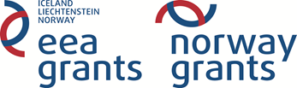
Fund for Bilateral Relations at National Level under the EEA FM and NFM 2009-2014
Nuclear Energy Decommissioning
Annex 1
---------------------------------------------------------------------------------------------------------------------------------------
Project Proposal

Project title:
Institution/Department/:
Name of the representative of the institution:
Contact details:
Project partner (s):
Project duration:
Project budget (in EUR):
Expected grant from the Fund for Bilateral Relations at National Level (in EUR):
Project objectives:
Project justification (please describe the identified issues of mutual interest/problems, planned activities and their justification in view of the objectives of the EEA FM and NFM):
Expected results:
Relevance to the bilateral cooperation objective, justification (describe the objectives of activities in relation to strengthening of the bilateral cooperation. How do the proposed activities contribute to achieving the bilateral cooperation objectives):
Previous cooperation (experience/history from involvement in initiatives dedicated to the same topic/field of cooperation and/or with the same partners):
Attachments: programme of events planned under the project; invitation from the partner (if applicable), other relevant documents in support of the justification.

Other information relevant to the proposed project:

Official representative of the institution /signature, stamp/:

