
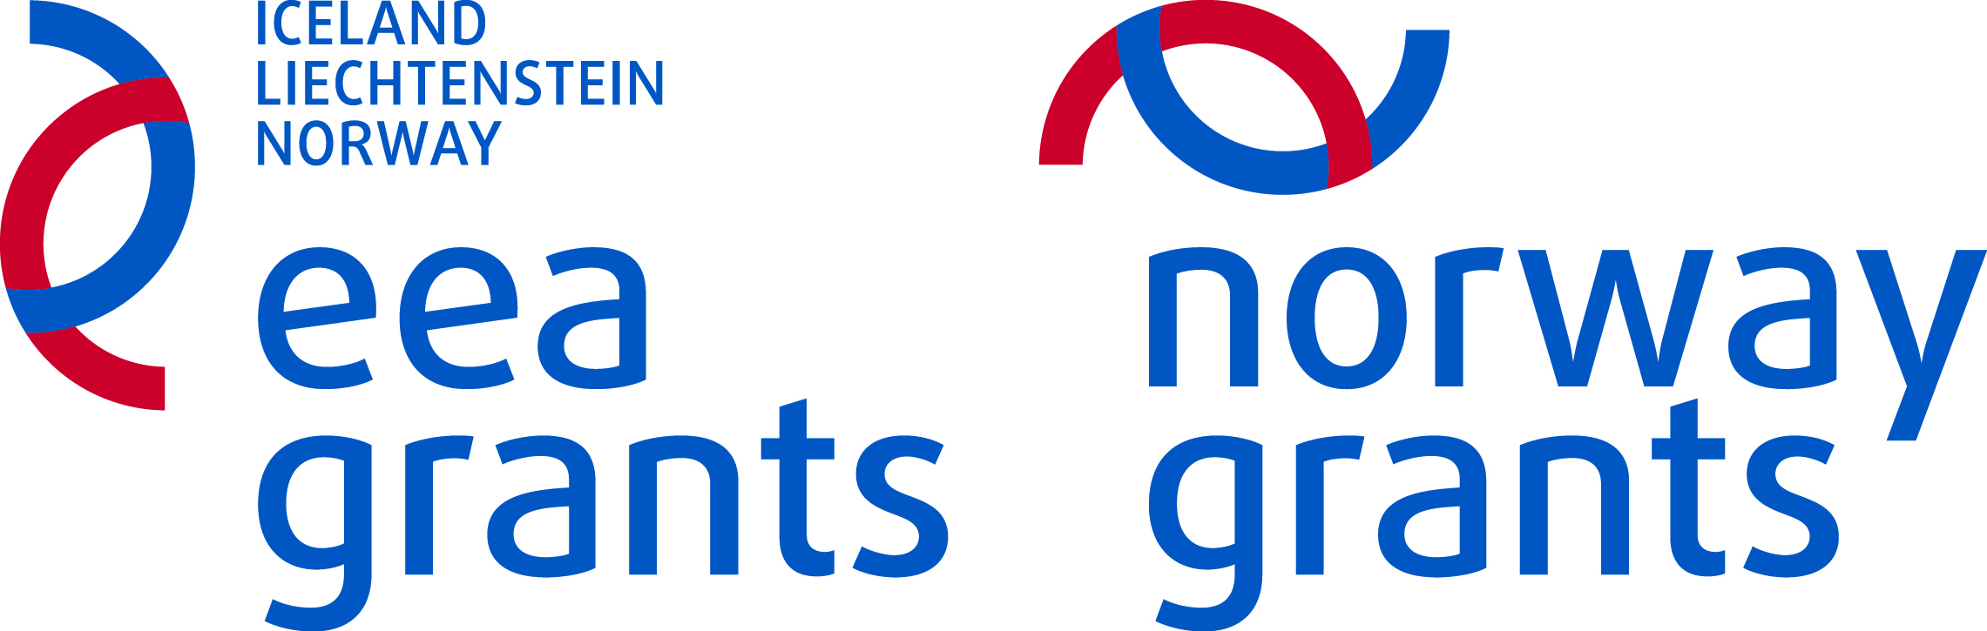

Annex 3.1.

PARTNERSHIP STATEMENT
Regarding the Project

………………………………………………………………………………………………..
(title of the project)

I, the undersigned:…………....................................................................................................,
(full names)
Personal ID No ………………
Identity document number …………………………, issued on………………………….. from………………………………….

Citizen of ……………………………………., address ............................................................., as a responsible official of ………………………………….…………………………………,
(title of the organisation)
With registration number …………………………….…..., participating as a Project partner of the following

Project promoter …………………………………………….................................................
(title of the organization submitting the project proposal as an applicant)
under the Fund for Bilateral Relations at National Level within the EEA Financial Mechanism and Norwegian Financial Mechanism 2009-2014, hereby

Do declare that:

1. the organisation I represent meets all eligibility criteria for project partners;
2. I am familiar with the project proposal and I am aware of the role the organization I represent will have in the project implementation. The involvement of the project partner in terms of roles and tasks to be performed under the activities set out in Annex 1 Project proposal, include (please provide description of the roles and tasks): ………………………………………………………………….…………...............................................................................................................................................................................................................................................................................................................................................
3. I am familiar with the eligible expenses covered by the Fund for Bilateral Relations at National Level, and I undertake to observe them during the project implementation;
4. the information about the Partner organisation I represent provided in the project proposal by the applicant is correct;
5. the organisation I represent has the necessary capacity to fulfill the tasks foreseen in the project proposal;
6. the organisation I represent will follow the publicity requirements while implementing the project activities;
7. all the documentation related to the project implementation will be kept for at least 5 (five) years after the approval of the final project report;
8. the organisation I represent will fulfill the requirement all the documentation related to the project implementation to be made available to external auditors during the project implementation phase as well as for 5 (five) years after the approval of the final project report;
9. I authorize the project promoter to represent the Partner organisation in communication with the National Focal Point regarding project implementation issues, including to sign the grant contract with the National Focal Point;
10. the organisation I represent will fulfill all the tasks foreseen in the project proposal and will provide all the necessary information upon a request of the project promoter.

Date: _______________ Signature: ______________________

Please note that the Partnership Statement has to be signed individually by each project partner envisaged in a project. It has to be signed by the official representative of the project partner or by an individual authorized with a power of attorney attached to this declaration.

